Writing Test-501
Q 1 The graph below shows the average Montreal temperature throughout the year. Summarise the information by collecting and reporting the main features and make comparisons where relevent.
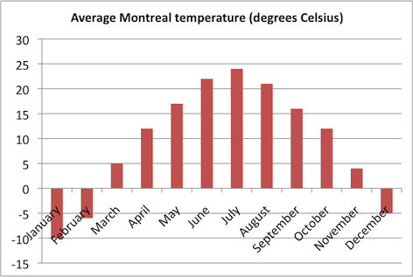

Task 2
Some people think that it is important to use leisure time for activities that improve the mind, such as reading and doing word puzzles. Other people feel that it is important to rest the mind during leisure time.

