Writing
Q: The bar chart shows the monthly spending in dollars of a family in the USA on three items in 2010. Summarize the information by selecting and reporting the main features and make comparisons where relevant. Write at least 150 words.
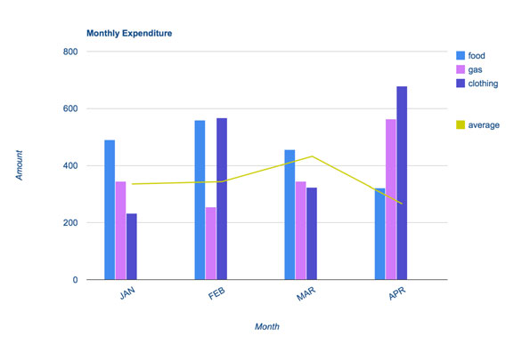
Task – 2
We have been living in the nuclear age now for over half a century. Since the first atomic bombs were developed, nuclear technology has provided governments with the ability to totally destroy the planet. Yet the technology has been put to positive use as an energy source and in certain areas of medicine.
To what extent is nuclear technology a danger to life on Earth? What are the benefits and risks associated with its use?

