Writing
Task 1
The bar chart below gives information about the number of students studying Computer Science at a UK university between 2010 and 2012. Summarize the information by selecting and reporting the main features, and make comparisons where relevant.
Write at least 150 words.
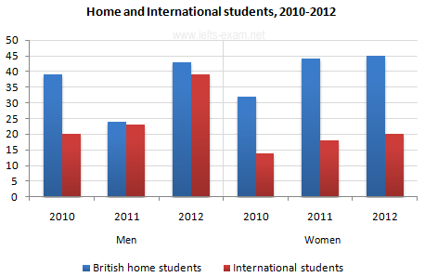
Task 2

