Writing
TASK 1
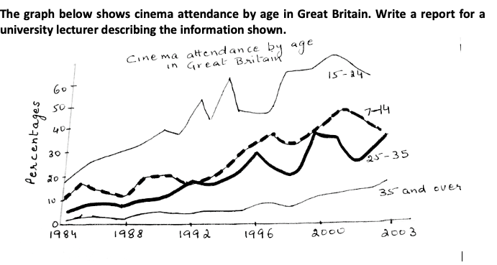

TASK 2
Some people think watching T.V is bad for children in every way others think T.V has positive effects on children as they grow up discuss both views and give you opinion.

