WRITING
Task 1
​The diagram below shows the process of using water to generate electricity for human use.
Summarise the information by selecting and reporting the main features, and make comparisons where relevant.
​
You should write at least 150 words and spend 20 minutes.
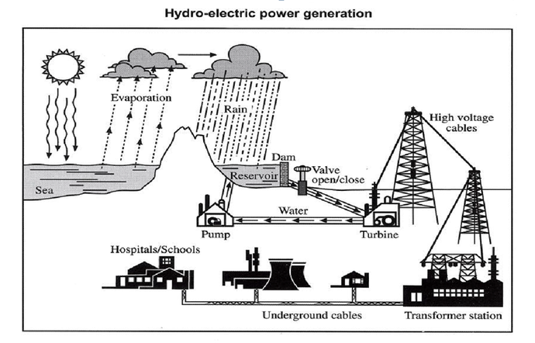
Task 2
In most countries, multinational companies and their products are becoming more and more important. This trend is seriously damaging our quality of life.
To what extent do you agree or disagree?

