LISTENING TEST 4_16
SECTION 1
Questions 1-10
Answer the following questions USING NO MORE THAN THREE WORDS.
EXAMPLE Where did the customer see the advertisement? On the internet
- Who is the customer buying the puppy for?
- When will the puppies be available?
- When is the breeder not available to meet?
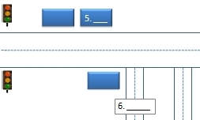
- What is outside the kennels?
Questions 5-6
Label the map using letters A- F below.
- Westlands Road
- Barnett Drive
- Banks Drive
- fruit and vegetable shop
- craft shop
- cafe
Questions 7-10
Complete the summary below using ONE WORD ONLY.
Micro-chipping pets is a secure way of keeping them safe. Collars and tags are convenient but can be removed or 7.______. Micro chips should be checked occasionally to make sure they are still working properly. The chips are about the same size as a grain of 8.______ and dogs should feel discomfort for no more than a few 9.______. Infection risk can be minimised by owners making sure the area does not become 10.______.

SECTION 2 Questions 11-20
Questions 11-13 Complete the sentences below. Write NO MORE THAN TWO WORDS AND/OR A NUMBER for each answer
Quartztown
- Quartztown was established in _______
- After the gold rush Quartztown’s economy relied on forestry, farming, _______and coal mining.
- _______ of the working age population work at the Delmer coalmine.

Question 14 – 15
Choose TWO letters A –E. Which two things have happened in Quartztown in the last 35 years
- Increase in people working in agriculture
- Growth of tourism
- A boom in the coal mining industry
- Development of outdoor activities
- Decline in visitors
Questions 16 – 20
Complete the summary below using NO MORE THAN TWO WORDS AND/OR NUMBERS
Quartztown first staged the Midwinter Festival in 16…………………………………. The festival opens with a parade with costumed character and floats displaying local and historical scenes. The floats are sponsored by 17………………………………………… Interactive light spectacles are projected on local buildings and the night ends with a impressive 18……………………………… show.
In the two weeks following there are events on the which include skiing, snowboarding and mountain biking. A marathon is held in 19…………………………………Valley. There are also activities for people who are more interested in craft, literature and music. Tours of the gold mining areas can be done on foot or on 20……………………………….
SECTION 3 Questions 21-30
Questions 21-24
Answer the following questions using NO MORE THAN THREE WORDS
21. What was face reading originally used to diagnose?
22. What can cause the same skin problems as alcohol?
23. What type of behaviour might someone with square facial features favour?
24. In contrast to a squarer faced receptionist, how can we expect one with rounded features to be?
Questions 25-28
Is the information in the following sentences TRUE, FALSE or NOT GIVEN according to the listening passage?
Write T, F or NG in boxes 25-28 of your answer sheet.
25. According to the research, sociable people are often not practical.
26. People with bright eyes are intelligent.
27. Physical characteristics often correlate with behaviour.
28. People with long thin noses and people with downward sloping eyes share a common characteristic.
Questions 29-30
Circle TWO letters
Which TWO of the following characteristics does the doctor say are true of people with high foreheads? Write your answers in boxes 29 and 30 of your answer sheet.
- Are hard workers
- Are often logical people
- Are quite serious
- Are likely to enjoy books
- Learn practically
SECTION 4 Questions 31-40
Questions 31 - 32
Choose TWO letters A - F. Identify TWO of the influences on the Bauhaus movement mentioned in the talk?
- Arts and Crafts movement
- Socialism
- Art noveau
- Functionalism
- Classicism
- Modernism
Question 33 – 35
What were the artistic occupations of the first faculty members at the Bauhaus in Weimer
Write the correct letter, A – D.
- Painter
- Writer
- Architect
- Sculptor
33. Walter Gropius and Adolph Meyer
34. Gerhard Marcks
35. Paul Klee and Wassily Kandinsky
Questions 36 – 37
Complete the sentences below using NO MORE THAN TWO WORDS AND/OR A NUMBER.
36. In the first year of the Bauhaus course students learnt about colour theory and basic ________.
37. Gropius’ aim was to create functional objects that were beautiful and that people could ________ .
38. Gropius designed a chair which was named the _______.

Question 39 and 40
Select the correct answer A-D.
39. Which picture shows a typical Bauhaus building?
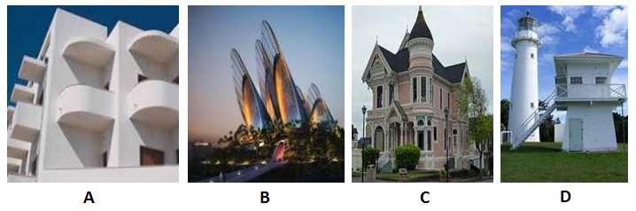
40. Which of the following is true of the Bauhaus school?
- The Weimar school was closed because of staff shortages
- The school in Dessau became a UNESCO World Heritage site in 1994
- Hannes Meyer became the head of the school
- The school prospered in the 1930s

