Writing

Task-1

The graph below shows the proportion of four different materials that were recycled from 1982 to 2010 in a particular country

Summarise the information by selecting and reporting the main features, and make comparisons where relevant.

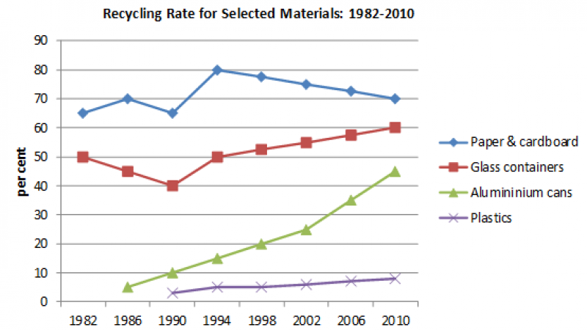

Task-2
1. Advances in technology and automation have reduced the need for manual labour. Therefore, working hours should be reduced.

