Writing

Task-1

The chart below shows the global sales of different kinds of digital games from 2000 to 2006.
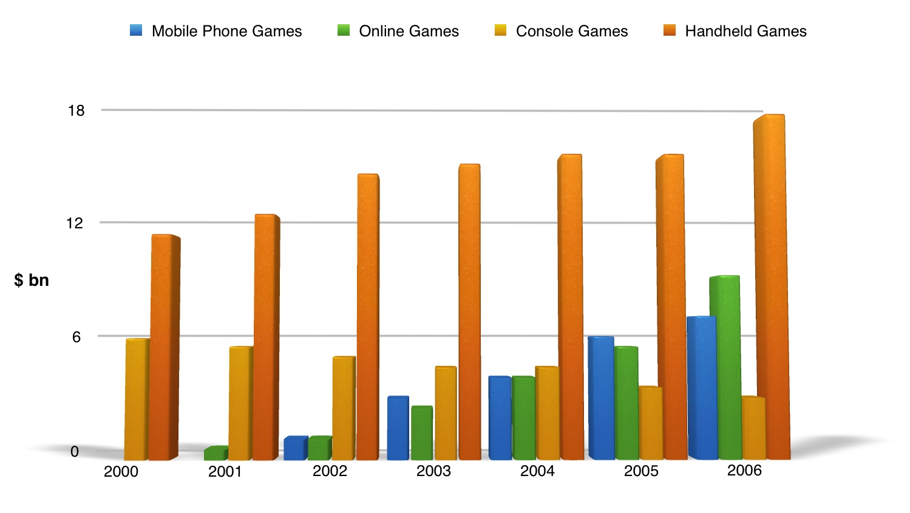

Task-2
1. Some people believe that teenagers should be required to do unpaid community work in their free time. This can benefit teenagers and the community as well.
To what extent do you agree or disagree.

