LISTENING TEST 4_18
Section 1 Questions 1-10
Complete the form below.
Write NO MORE THAN TWO WORDS / OR A NUMBER for each answer.
Tourism Survey
Example Answer
Name: Robert Goddard
Destination: Melbourne
Total number of visits: 1)…………………
Best thing about the city: 2)…………………
Favorite attraction: 3)…………………
Best thing about
The destination’s dining options: 4)………………….
Method of transport
To destination: by 5)………………
Age group: 6)………………….
Income level: 7)………………….
Purpose of visit: - on business
- 8)……………….
Occupation: - 9)…………………
- writer for a travel magazine
Opinion of cost of accommodation: 10)…………………

Section 2 Questions 11-20
Questions 11-15
Label the map below.
Write the correct letter, A-E, next to questions 11-15.
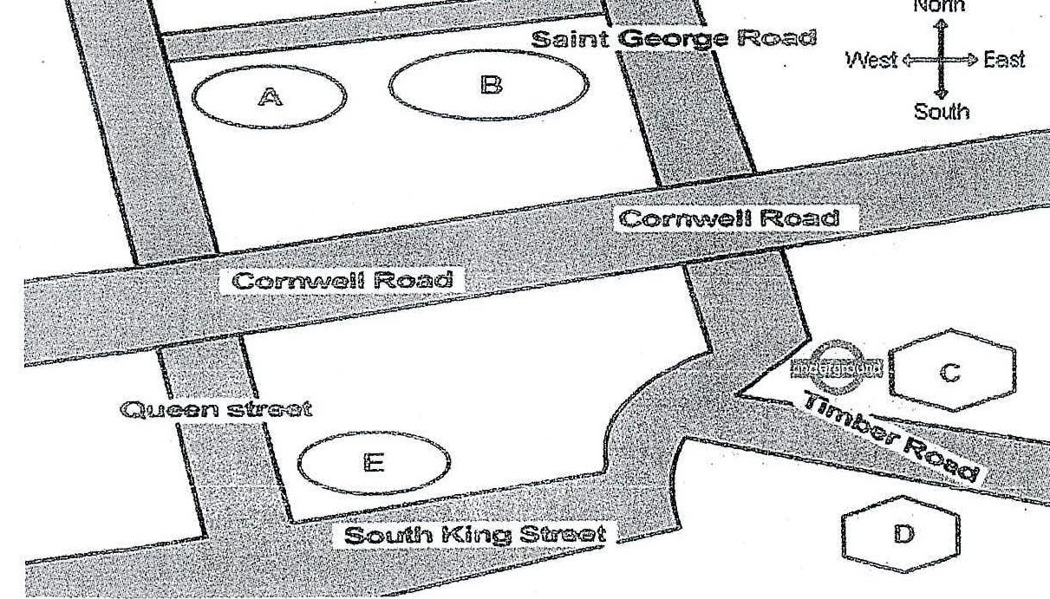
11. Science Museum ………………….
12. National History Museum ………………….
13. Car Park ………………….
14. Shopping Mall ………………….
15. Primary School ………………….

Questions 16-20
What is the improvement of each main point of interest in the area?
Choose FIVE answers from the box and write the correct letter, A-G, next to questions 16-20.
A New entrance
B Free lunch provided
C Free information provided
D increase in size
E Additional signs
F New exhibitions
G New structure

16 Car Park ………………………..
17 Primary School ………………………..
18 Science Museum ………………………..
19 National History Museum ………………………..
20 Shopping Mall ………………………..

Section 3 Questions 21-30
Questions 21-23
Choose the correct letter, A, B or C
21. The proposal will
A. be reviewed by two examiners.
B. be added to the final grade,
C. be returned with feedback.
22. The proposal will consist mostly of
A. topics.
B. methods.
C. results.
23. For the practice paper, the tutor has directed the students to make sure to
A. pay attention to time limits.
B. write at least 6,000 words.
C. keep on topic.
Questions 24-30
Complete the sentences below.
Write ONE WORD AND /OR A NUMBER for each answer.
24. There is no need to …………......lots of people.
25. Pay attention to the …………...... of the final report.
26. Prepare …............, one for the teacher, another for the students themselves.
27. The deadline of the final paper is…………......
28. The students can…………….their topics before the beginning of April.
29. Students deciding to change topics must deliver a …………......to the teacher in advance.

30. At the beginning of the report, the hypothesis and an outline of the …………......are needed.
Section 4 Questions 31-40
Complete the notes below.
Write NO MORE THAN TWO WORDS for each answer.
Advertising Effect
The important factor to consider
- The 31) . . . . . . . . . . . . customers must travel affects the probability that they will buy the product.
Methods of communication
- Advertising slogans are easier to remember it there is a 32) . . . . . . . . . . . . played with them.
- Mandy’s Candy Store appeals to people’s sense of 33) . . . . . . . . . . . . to draw in customers.
- To an ad campaign for digital products, it is 34) . . . . . . . . . . . . that is extremely important
- Effect on your product sales
- The customer’s 35) . . . . . . . . . . after he or she experiences the ad is most important.
Marketing strategies
- On international flights, it is wise for advertisements to be displayed in the common 36)……………. of most passengers.
- Very few young people buy 37) . . . . . . . . . . . . .
- The UNESCO website would be a good place to advertise for companies aiming to
improve the 38) . . . . . . . . . . . . .
- One good location to place ads for sunscreen is the 39) . . . . . . . . . . . . .
- A good scene for a water purification commercial would be 40) . . . . . . . . . . . . .

