Writing

Task-1

The pie charts below show the average household expenditures in a country in 1950 and 2010.
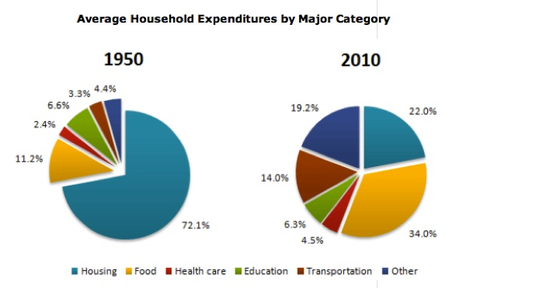

Task-2
1. Some people think that children's free time must include educational activities otherwise they will waste their time.What is your opinion?

