Writing

Task-1

The process that is used to manufacture bricks for the building industry.

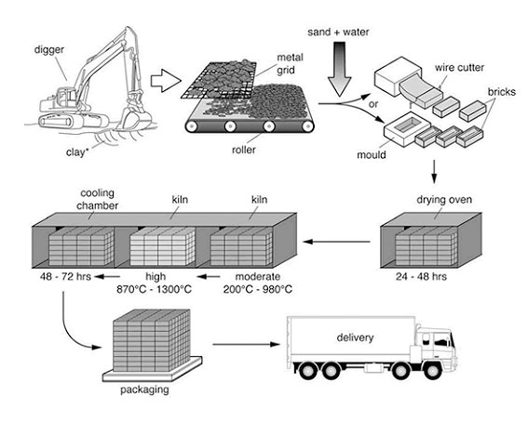

Task-2
1. Nowadays, distance-learning programs have gained popularity, but some people argue that online courses can never be as good as those taken at a college or university in person. To what extent do you agree or disagree?

