Writing

Task-1
The electricity generated in Germany and France from all sources and renewables in the year 2009.

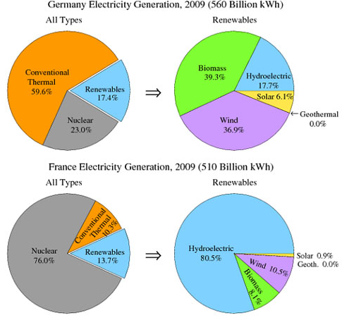
Task-2
The increase in the production of consumer goods results in damage to the natural environment. What are the causes of this? What can be done to solve this problem?

