WRITING
Task 1
​The table below gives information about the employment sectors in which people from 3 age groups worked.
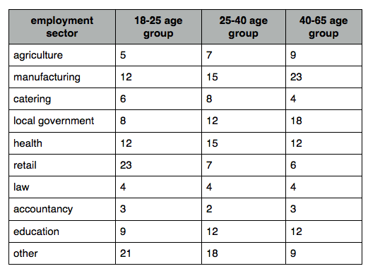

Task 2
Some people think international events such as the Olympic Games are important and can bring nations together. Others, however, think that they are a waste of money as the money could be spent elsewhere on more important issues. Discuss both these views and give your own opinion.

