WRITING
Task 1
​The different modes of transport used to travel to and from work in one European city in 1960, 1980 and 2000.
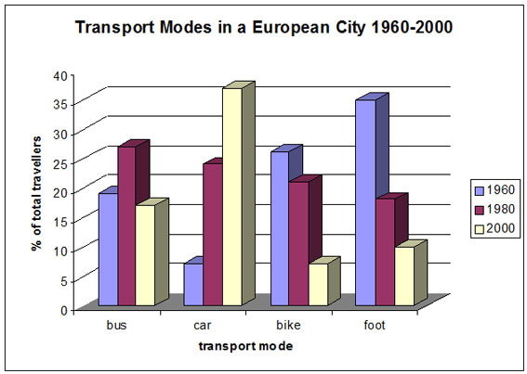

Task 2

Artists need a certain amount of freedom to develop their creativity. Some people think that artists should have total freedom to express any thoughts and ideas. To what extent do you agree or disagree?

