Writing

Task-1

British Emigration to selected destinations between 2004 and 2007.

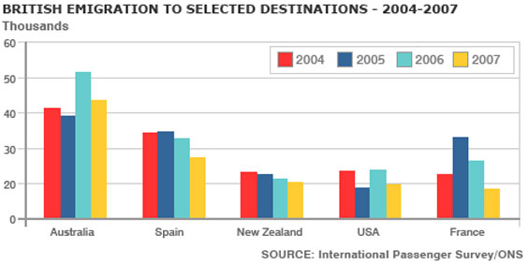

Task-2
Advanced technology has brought many beneficial changes to the world. However, some old people today struggle with the use of technologies such as mobile phones and the Internet. How can the elderly benefit from using advanced technologies? How can the elderly be encouraged to use consumer electronics more often?

