LISTENING TEST 4_17
SECTION 1 Questions 1-10
Questions 1-2
Answer the following questions using NO MORE THAN TWO WORDS.
EXAMPLE: Approximately how long has the caller lived in the city? 10 days
1. When does the renter want to decide who will move in?
2. When do they actually decide to meet?

Questions 3 and 4
Which TWO of the following does the renter say the tenant will have in the room? Write the correct letters in boxes 3 and 4 of your answer sheet.
A A new mattress
B A desk
C A chair
D A TV
E A chest of drawers
F A telephone

Questions 5-7
Complete the sentences below. Use NO MORE THAN THREE WORDS OR A NUMBER for each answer
The house has three floors and (5) ___________________ bedrooms.
The top floor contains one bedroom and a (6)___________________
The property also has a separate (7)_____________________
for the landlord’s guests on the ground floor

Questions 8-10
Choose the appropriate letters A-D and write the correct answers in boxes 8-10 on your answer sheet.
8. The tenant will often have the kitchen to themselves because:
a. the students have a separate kitchen
b. the students often eat dinner at work
c. the landlady cooks for the students
d. the students always have takeaways
9. The dryer for clothes is
a. in the kitchen
b. on the terrace
c. on the ground floor
d. not for use by tenants
10. At three o’clock the landlady might:
a. be gardening
b. still be meeting with other people
c. be at work
d. be upstairs

SECTION 2 Questions 11-20
Questions 11-13
Complete the summary that follows using NO MORE THAN TWO WORDS for each answer.
The chef says that the dish she is cooking is ideal for a family dinner or a 11. ______ for adults requiring very little change. The chicken breasts should be cooked in a 12.______ oven dish. The chef gives useful tips on how a fan in an oven can evenly distribute 13.______

Questions 14-15
Which TWO of the following does the chef say are true of the herb oregano?
A It’s easy to sprinkle on food
B It’s tastier when fresh
C It’s used in the majority of Italian dishes
D It has a lemony flavour
E It gives food a rounded flavour
F It’s a good accompaniment to many meat dishes

Questions 16-20
Complete the notes below. Write NO MORE THAN THREE WORDS for each answer.
Chicken with Feta Cheese
- Feta is from the Balkan countries and is a cheese with a 16.______ texture.
- For this dish you’d ideally need 17.______ pieces per person.
- Adding 18.______ is not necessary due to the flavour of the feta.
- Families might enjoy the dish along with steamed vegetables and 19.______.
- Chicken thighs might be easier to cook than white meat because they are less likely to 20.______.

SECTION 3 Questions 21 - 30
Complete the flowchart using NO MORE THAN TWO WORDS for each answer.
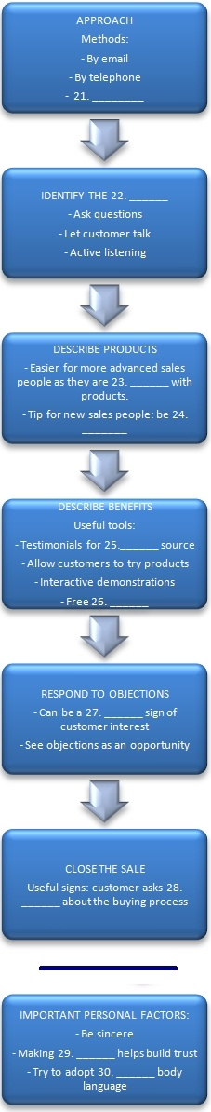
SECTION 4 Questions 31-40
Questions 31-33
Choose the correct letter A, B or C.
- Using the internet for research
  - Is increasingly discouraged for academic study
  - Has more dangers than advantages
  - Is sometimes the only way to access certain materials
- One of the main risks of internet research is
  - Web pages are increasingly difficult to update
  - People in the same field may not have had the opportunity to comment on its value
  - Information is potentially copyrighted
- One well know website
  - Has purposefully added erroneous information
  - Is considering allowing users to make modifications to texts
  - Has suffered from users entering false or misleading information

Questions 34-40
Complete the summary below using NO MORE THAN TWO WORDS OR A NUMBER
The CARS method of evaluating internet sources

Credibility:
- who is [34]______ for the information given
- where they are (a [35]_______ to know exactly where the author(s) are based).

Accuracy:
- be aware of errors in grammar and spelling
- check for a [36]_______ stamp

Reasonableness
- should be written neutrally without being excessively emotional
- check that the web address is [37]______ to material you are researching
- [38]______ should not be mixed with the main content of the site

Support
- Make sure all claims can be substantiated
- Sources should be cited
- Corroborate information with at least [39]_______ sites.
General note: as well as the CARS test, a good indicator of useful information is [40]_______

