Writing

Task-1

Visits to and from the UK from 1979 to 1999, and the most popular countries visited by UK residents in 1999.
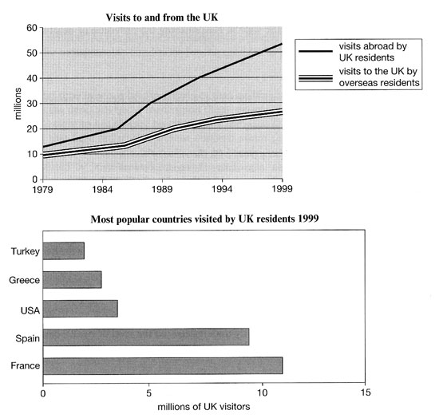

Task-2
Education is not a luxury, but a basic human right and as such should be free for everyone irrespective of personal wealth.
Do you agree or disagree?

