Writing

Task-1

The process that is used to manufacture bricks for the building industry.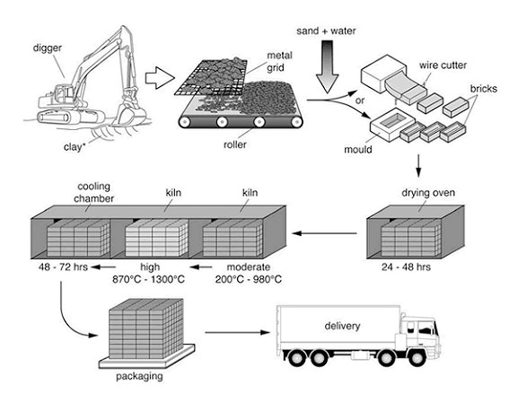

Task-2
Government investment in the arts, such as music and theatre, is a waste of money. Governments must invest this money in public services instead.
To what extent do you agree with this statement?

