Writing

Task-1

The percentage of persons arrested in the five years ending 1994 and the most recent reasons for arrest.

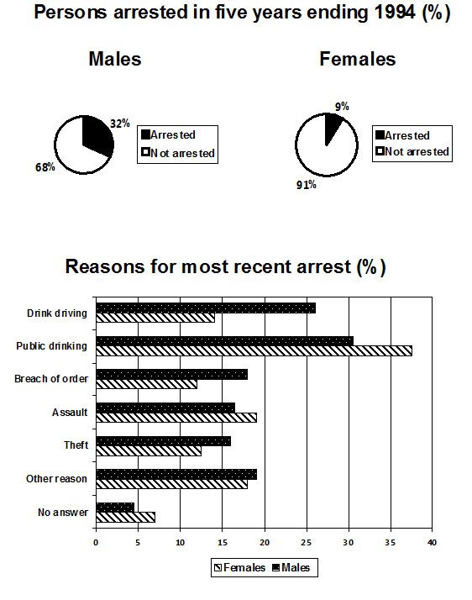

Task-2

Advanced technology has brought many beneficial changes to the world. However, some old people today struggle with the use of technologies such as mobile phones and the Internet. How can the elderly benefit from using advanced technologies? How can the elderly be encouraged to use consumer electronics more often?

