Writing

Task-1

How chocolate is produced.

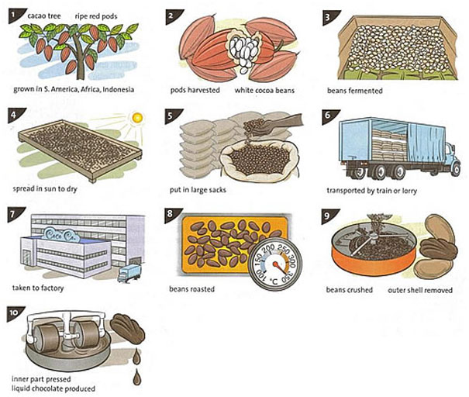

Task-2

Developed countries have created many environmental problems in the World, particularly in their contribution to global warming.
Why is global warming a problem?
What can be done to reduce the dangers of global warming?

